**In Part 3, I successfully coded the blocking squares to be placed intelligently in good formations. For example, running these codes from Eckel’s lab assignment gives:**

Your_code.py 13x13 32 wordlist.txt V2x4# V1x9# V3x2# h8x2#moo# v5x5#two# h6x4#ten# v3x7#own# h4x6#orb# h0x5Easy

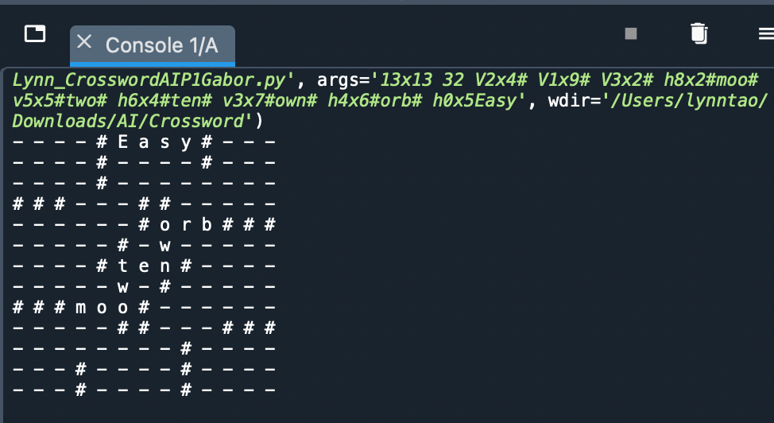

Your_code.py 15x15 42 wordlist.txt H0x0#MUFFIN#BRIOCHE V0x7## H3x3# H3x8# H3x13## H4x4# H4x10## H5x5# H5x9## H6x0### H6x6# H6x10# H7x0## H14x0BISCUIT#DANISH

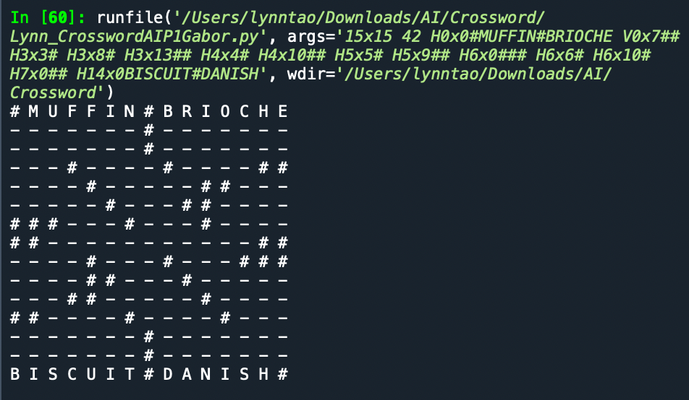

**These two examples show that I satisfied the Part 3 Conditions of creating a “smart” algorithm that arranged blocking squares in an optimal manner for crossword solving.**